Skewness

Definition
# Source: AI Source: Provided by: [Data Path: Persons Table -> ID Column: 1, Name_En Column: Motasem Essam] -> From: [ChatGPT] on [7/25/2026]
Skewness is a geometric relationship between two lines in three-dimensional space that:
- Do not intersect, and
- Are not parallel, and
- Do not lie in the same plane.
Such lines are called skew lines.
In other words:
Two lines are skew if they are non-parallel, non-intersecting, and non-coplanar.
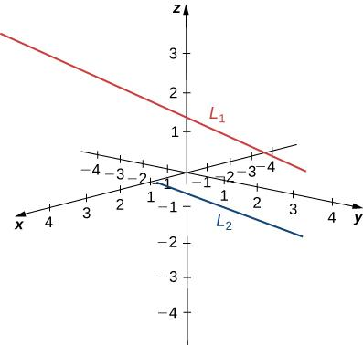
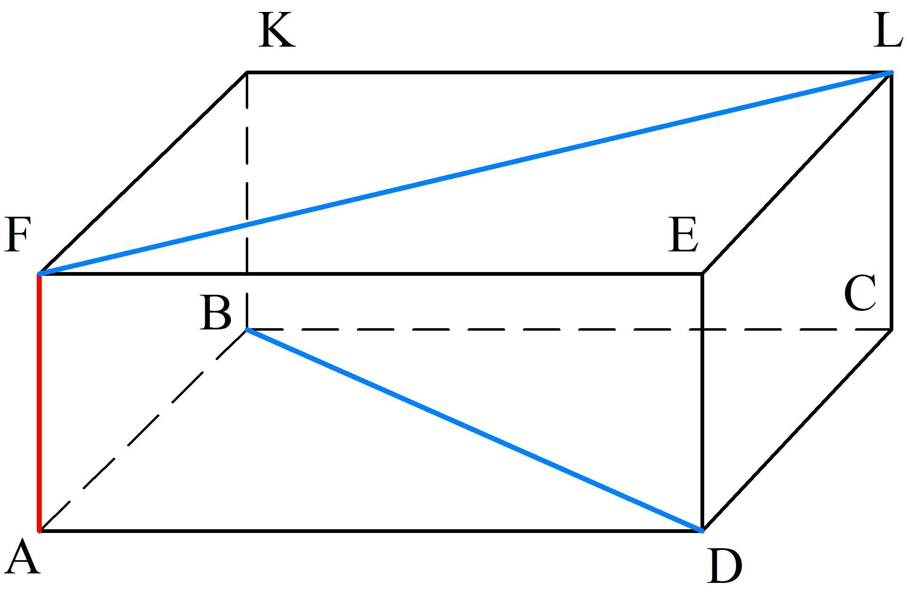
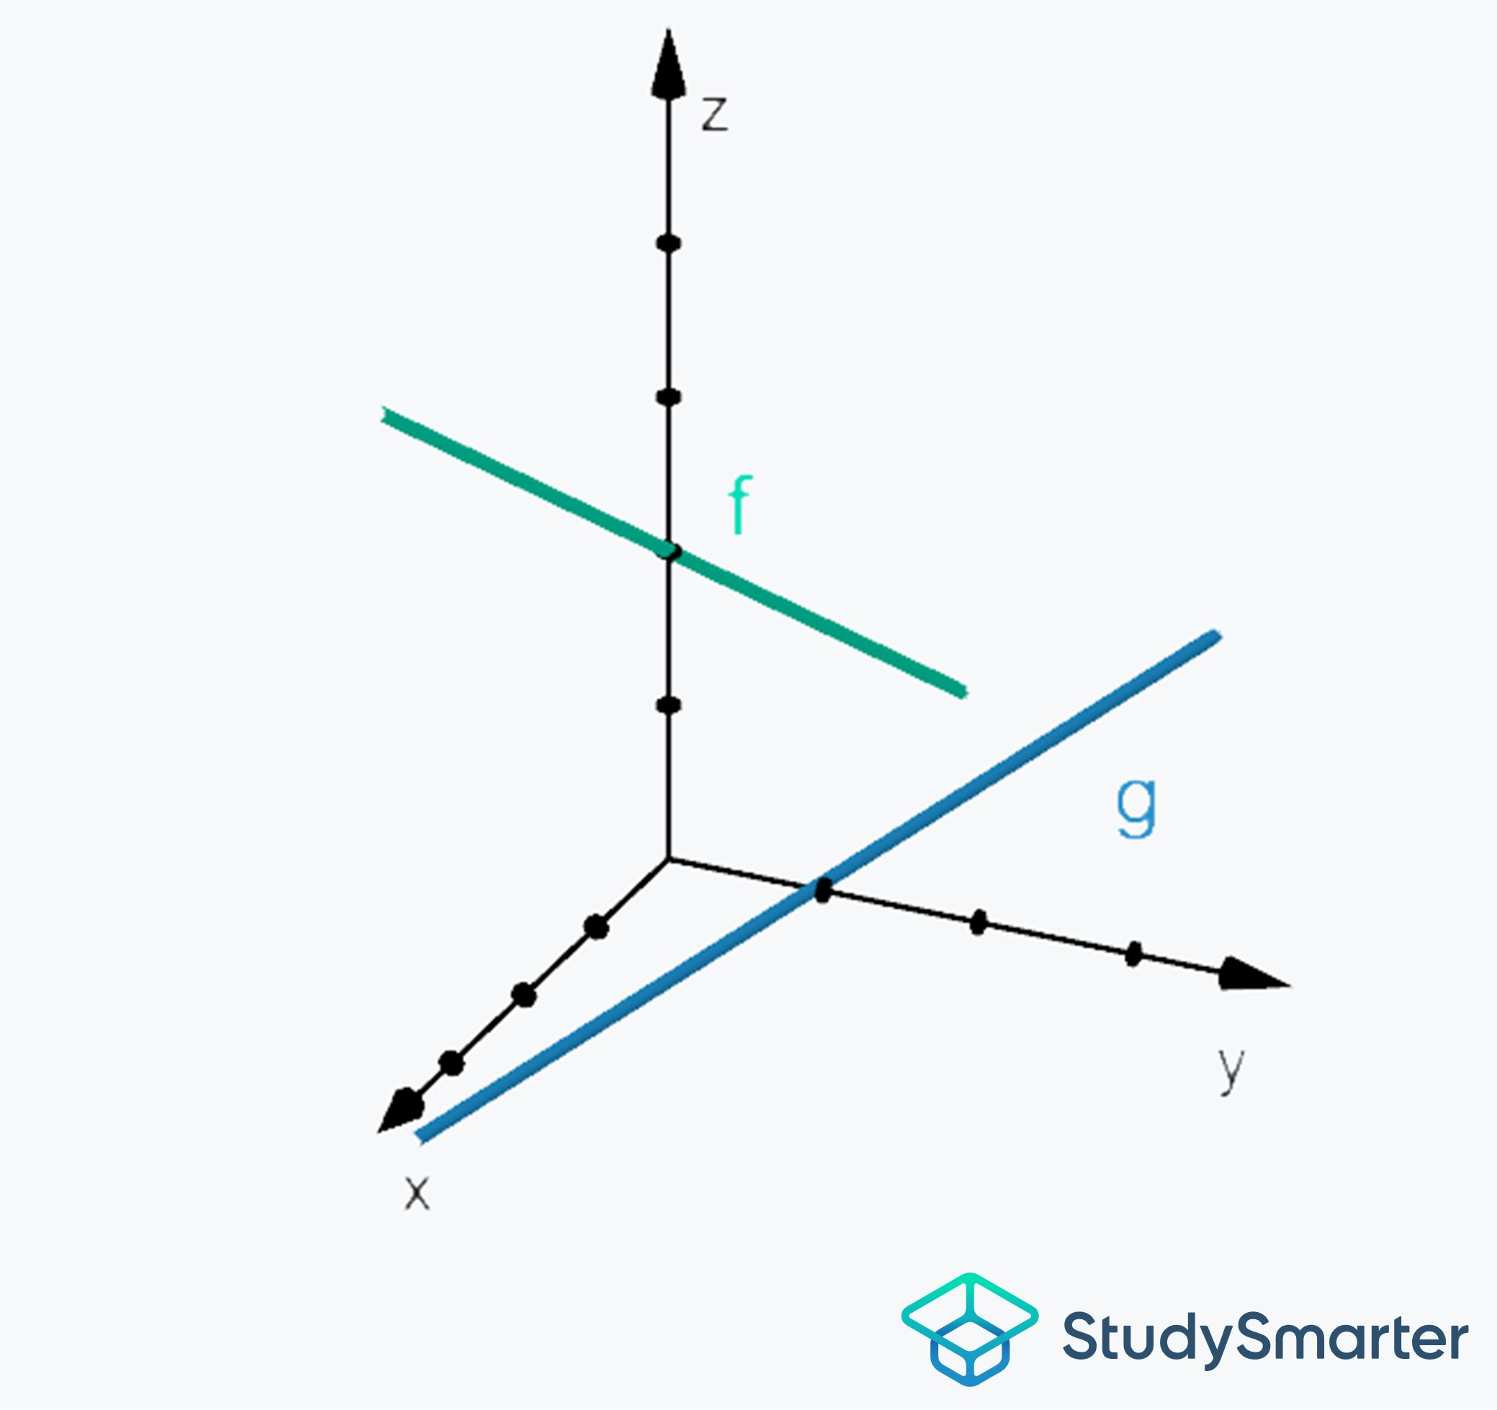
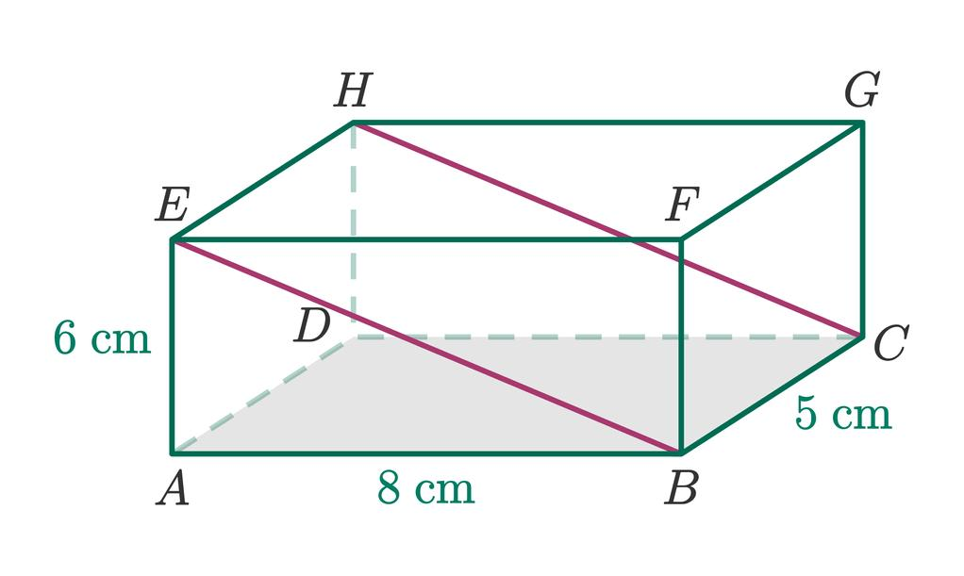
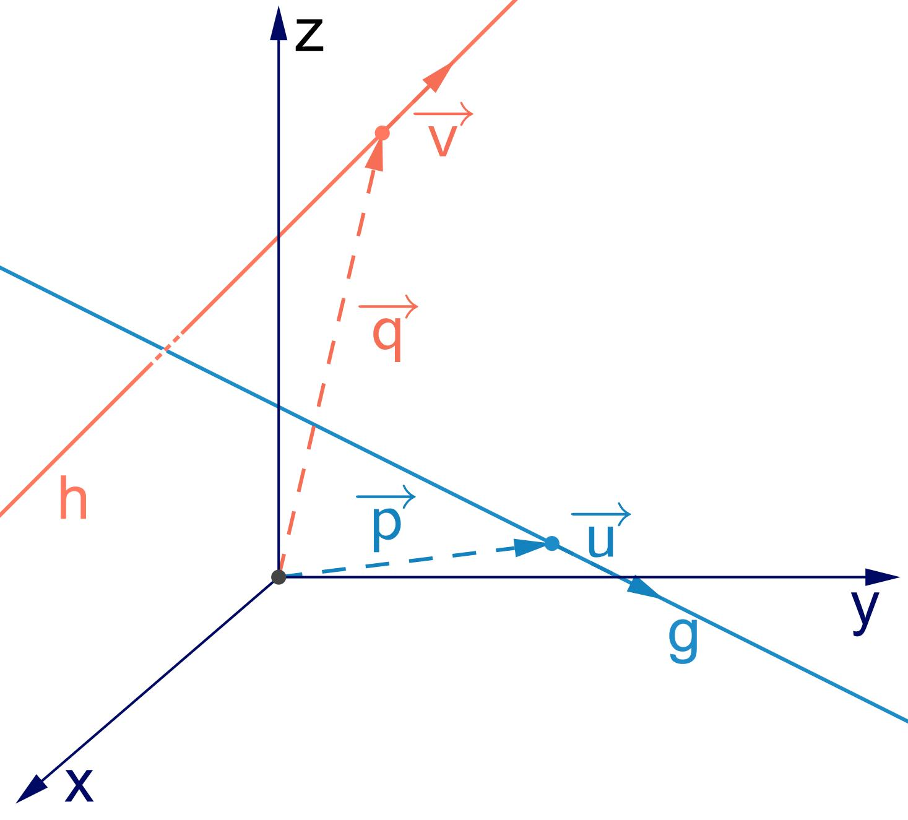

Purpose
# Source: AI Source: Provided by: [Data Path: Persons Table -> ID Column: 1, Name_En Column: Motasem Essam] -> From: [ChatGPT] on [7/25/2026]
Skewness is used to describe the relative position of lines in three-dimensional geometry.
It helps to:
- Identify relationships between lines in 3D space.
- Distinguish non-coplanar lines from parallel and intersecting lines.
- Analyze the structure of 3D geometric objects.
- Study spatial geometry and solid geometry.
- Determine the shortest distance between two non-intersecting lines.

Fundamental Characteristics
# Source: AI Source: Provided by: [Data Path: Persons Table -> ID Column: 1, Name_En Column: Motasem Essam] -> From: [ChatGPT] on [7/25/2026]
For two lines l_1 and l_2 to be skew:

1. They do not intersect
# Source: AI Source: Provided by: [Data Path: Persons Table -> ID Column: 1, Name_En Column: Motasem Essam] -> From: [ChatGPT] on [7/25/2026]
There is no point common to both lines:
$$l_{1}∩l_{2}=∅$$

2. They are not parallel
# Source: AI Source: Provided by: [Data Path: Persons Table -> ID Column: 1, Name_En Column: Motasem Essam] -> From: [ChatGPT] on [7/25/2026]
Their direction vectors are not scalar multiples:
$${\vec{d}}_{1}≠k{\vec{d}}_{2}$$
for any scalar k.

3. They are non-coplanar
# Source: AI Source: Provided by: [Data Path: Persons Table -> ID Column: 1, Name_En Column: Motasem Essam] -> From: [ChatGPT] on [7/25/2026]
There is no single plane containing both entire lines.
Therefore:
$$\boxed{\text{Skew}=\text{Non-intersecting}+\text{Non-parallel}+\text{Non-coplanar}}$$

Skewness Occurs Only in Three Dimensions
# Source: AI Source: Provided by: [Data Path: Persons Table -> ID Column: 1, Name_En Column: Motasem Essam] -> From: [ChatGPT] on [7/25/2026]
Skew lines cannot exist in ordinary two-dimensional plane geometry.
In a plane, two distinct lines must either:
- intersect, or
- be parallel.
There is no third possibility.
In three-dimensional space, however, two lines can avoid each other without being parallel because they can occupy different planes.
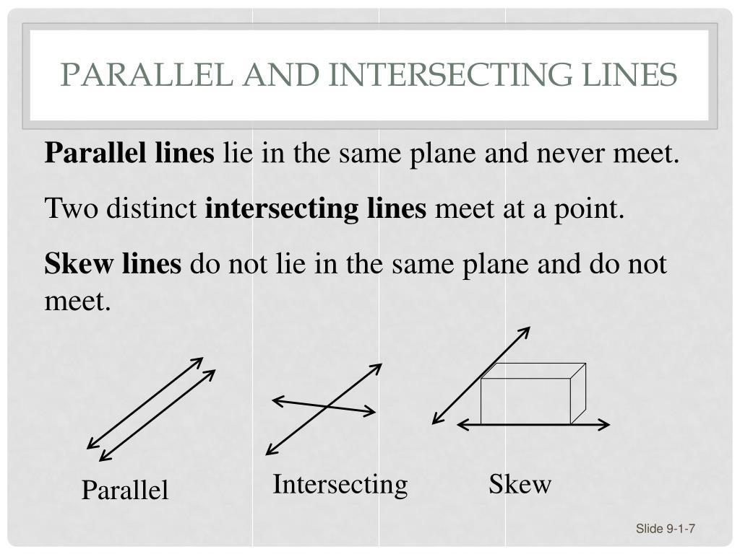
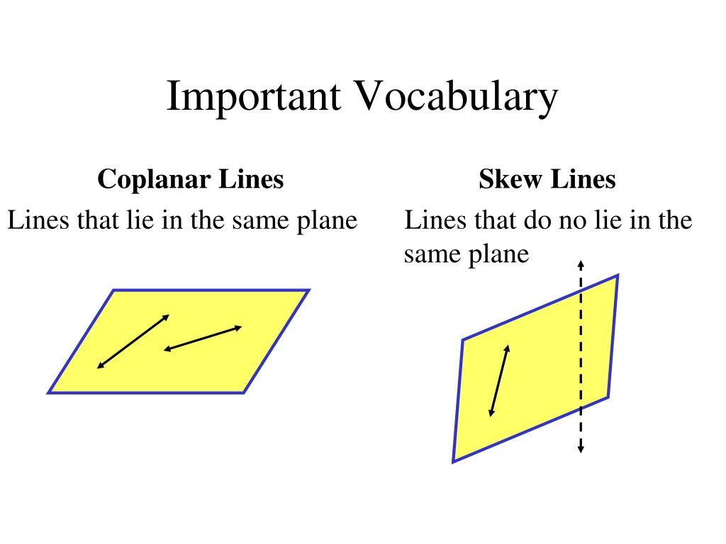
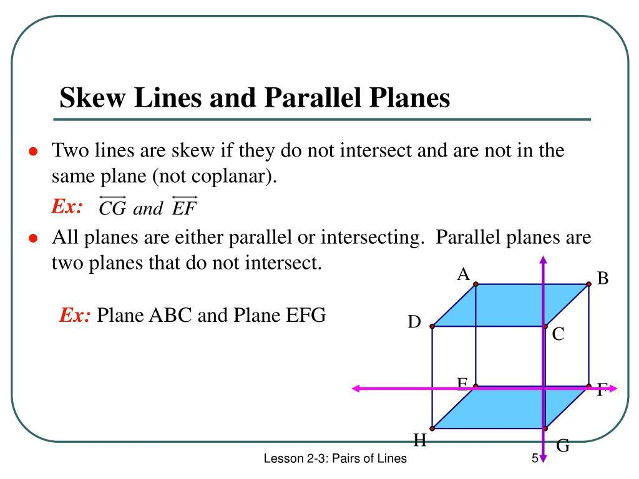
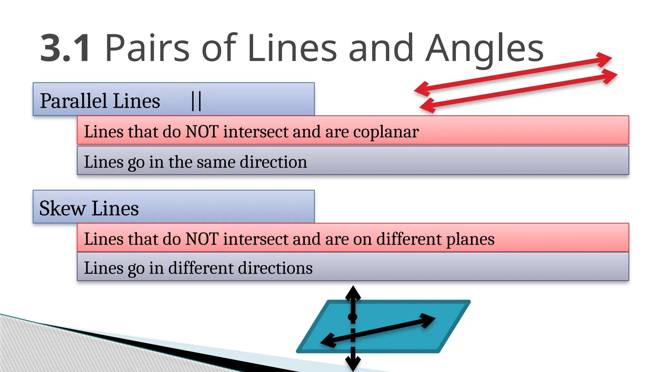

Mathematical Representation
# Source: AI Source: Provided by: [Data Path: Persons Table -> ID Column: 1, Name_En Column: Motasem Essam] -> From: [ChatGPT] on [7/25/2026]
Consider two lines in R^3:
$$L_{1}:\vec{r}=\vec{a}+t\vec{u}$$
and
$$L_{2}:\vec{r}=\vec{b}+s\vec{v}$$
where:
- \vec a, \vec b are position vectors,
- \vec u, \vec v are direction vectors,
- t and s are real parameters.
The lines are skew when:
Direction vectors are not parallel
$$\vec{u}×\vec{v}≠\vec{0}$$
and the lines do not intersect.
A useful test is:
$$\boxed{\left(\vec{b}-\vec{a}\right)⋅\left(\vec{u}×\vec{v}\right)≠0}$$
This nonzero scalar triple product means that the two lines are not coplanar, so if they are also non-parallel, they are skew.

Example 1 – Identifying Skew Lines
# Source: AI Source: Provided by: [Data Path: Persons Table -> ID Column: 1, Name_En Column: Motasem Essam] -> From: [ChatGPT] on [7/25/2026]
Consider two lines in 3D:
$$L_{1}:\left(x , y , z\right)=\left(t , 0 , 0\right)$$
and
$$L_{2}:\left(x , y , z\right)=\left(0 , s , 1\right)$$
The first line lies along the x-axis.
The second line lies at z=1 and extends in the y-direction.
Their direction vectors are:
$$\vec{u}=\left(1 , 0 , 0\right) \\ \vec{v}=\left(0 , 1 , 0\right)$$
These are not parallel.
Could they intersect?
For L_1:
$$y=0, z=0$$
For L_2:
$$x=0, z=1$$
They cannot have the same point because one requires z=0 while the other requires z=1.
They are therefore non-intersecting.
Furthermore, they are not contained in one plane.
Therefore:
$$\boxed{L_{1}\text{ and }L_{2}\text{ are skew lines}}$$

Example 2 – Skew Lines on a Cuboid
# Source: AI Source: Provided by: [Data Path: Persons Table -> ID Column: 1, Name_En Column: Motasem Essam] -> From: [ChatGPT] on [7/25/2026]
Consider a rectangular box.
One line can be drawn along the front bottom edge, while another line is drawn along a back vertical edge.
The two lines:
- do not intersect,
- are not parallel,
- do not lie in the same plane.
Therefore, they are skew lines.
This is one of the easiest physical ways to visualize skewness.

Skew Lines and the Shortest Distance
# Source: AI Source: Provided by: [Data Path: Persons Table -> ID Column: 1, Name_En Column: Motasem Essam] -> From: [ChatGPT] on [7/25/2026]
An important property of skew lines is that there is a unique shortest distance between them.
If
$$L_{1}:\vec{r}=\vec{a}+t\vec{u}$$
and
$$L_{2}:\vec{r}=\vec{b}+s\vec{v}$$
are skew lines, their shortest distance is:
$$\boxed{d=\frac{∣\left(\vec{b}-\vec{a}\right)⋅\left(\vec{u}×\vec{v}\right)∣}{∣\vec{u}×\vec{v}∣}}$$
This distance is measured along a direction perpendicular to both lines.
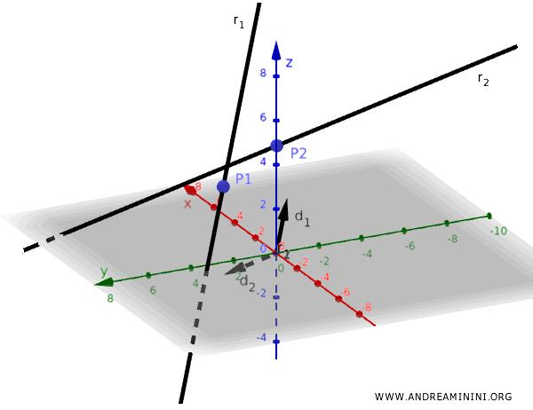
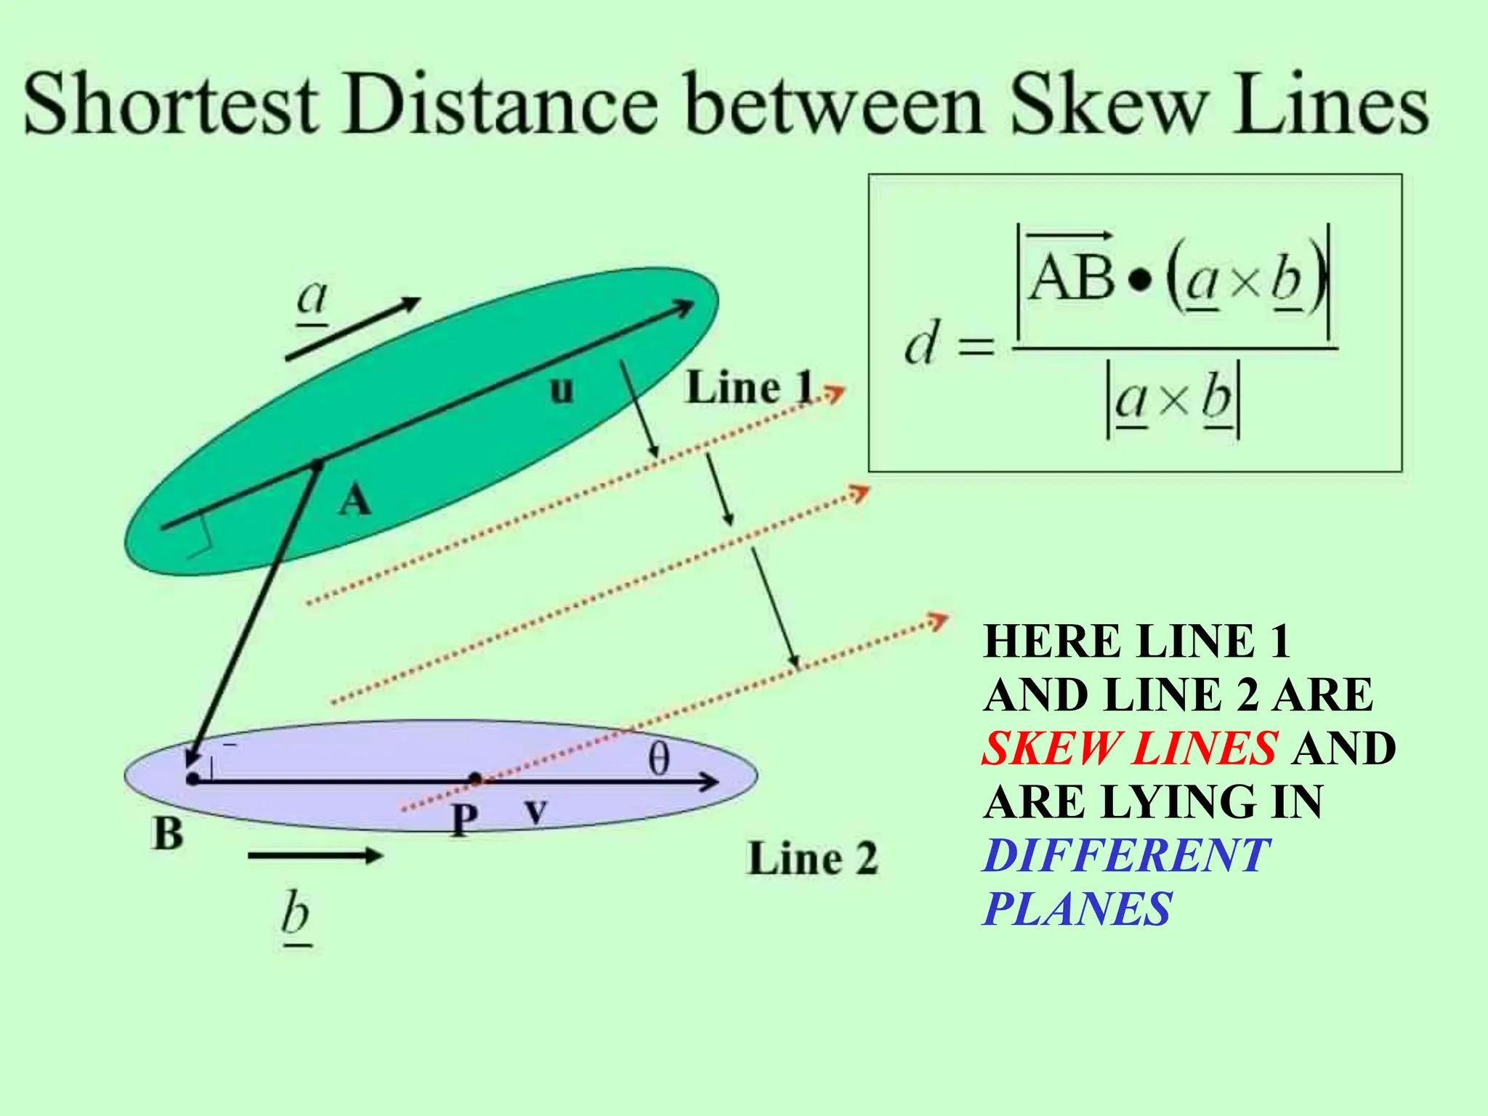
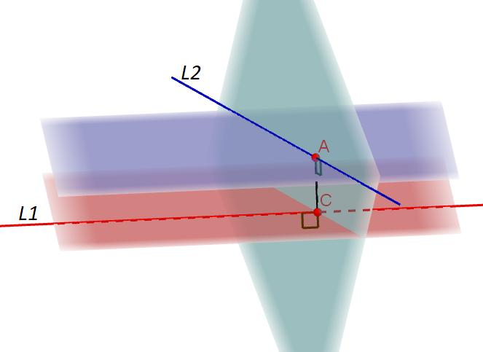
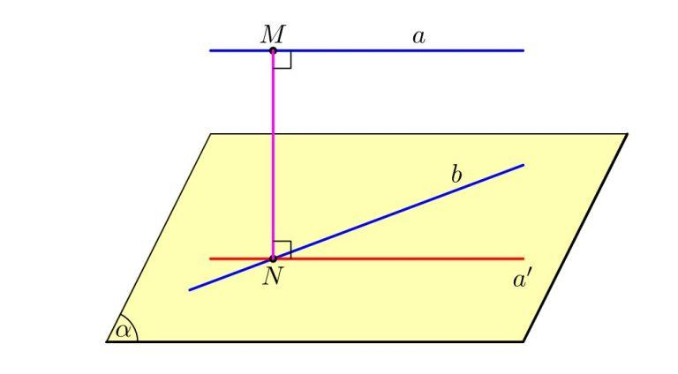
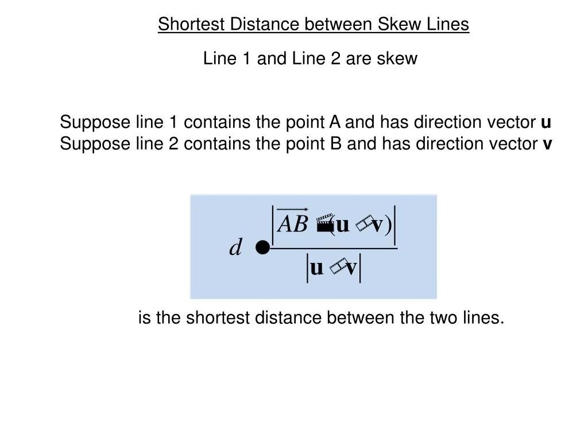

Common Perpendicular
# Source: AI Source: Provided by: [Data Path: Persons Table -> ID Column: 1, Name_En Column: Motasem Essam] -> From: [ChatGPT] on [7/25/2026]
The shortest segment connecting two skew lines is perpendicular to both lines.
If the common perpendicular has direction vector
$$\vec{n}=\vec{u}×\vec{v}$$
then:
$$\vec{n}⊥\vec{u}$$
and
$$\vec{n}⊥\vec{v}$$
Therefore, the shortest distance between skew lines is measured in a direction perpendicular to both.

Skewness vs Other Line Relationships
# Source: AI Source: Provided by: [Data Path: Persons Table -> ID Column: 1, Name_En Column: Motasem Essam] -> From: [ChatGPT] on [7/25/2026]
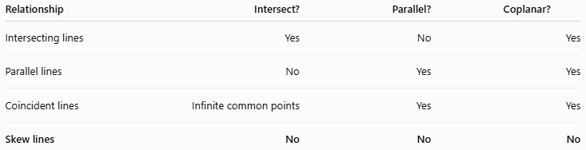
Relationship | Intersect? | Parallel? | Coplanar?
Intersecting lines | Yes | No | Yes
Parallel lines | No | Yes | Yes
Coincident lines | Infinite common points | Yes | Yes
Skew lines | No | No | No
The defining feature of skewness is non-coplanarity.

Skewness vs Parallelism
# Source: AI Source: Provided by: [Data Path: Persons Table -> ID Column: 1, Name_En Column: Motasem Essam] -> From: [ChatGPT] on [7/25/2026]
Parallel lines:
$$l_{1}∥l_{2}$$
are always contained in the same plane.
Skew lines:
$$l_{1}∦l_{2}$$
and do not intersect, while also being non-coplanar.
Therefore:
$$\boxed{\text{Parallel lines are coplanar; skew lines are non-coplanar.}}$$

Skewness vs Intersection
# Source: AI Source: Provided by: [Data Path: Persons Table -> ID Column: 1, Name_En Column: Motasem Essam] -> From: [ChatGPT] on [7/25/2026]
Intersecting lines have at least one common point:
$$l_{1}∩l_{2}≠∅$$
Skew lines have no common point:
$$l_{1}∩l_{2}=∅$$
However, skew lines are different from parallel lines because they are not coplanar.

Skewness vs Coincidence
# Source: AI Source: Provided by: [Data Path: Persons Table -> ID Column: 1, Name_En Column: Motasem Essam] -> From: [ChatGPT] on [7/25/2026]
Coincident lines occupy exactly the same geometric location:
$$l_{1}=l_{2}$$
They therefore have infinitely many common points.
Skew lines have no common points:
$$l_{1}∩l_{2}=∅$$
and are non-coplanar.

Important Properties
# Source: AI Source: Provided by: [Data Path: Persons Table -> ID Column: 1, Name_En Column: Motasem Essam] -> From: [ChatGPT] on [7/25/2026]
- Skewness is primarily a 3D spatial relationship.
- Skew lines do not intersect.
- Skew lines are not parallel.
- Skew lines are non-coplanar.
- Skew lines cannot exist as two distinct lines in a single plane.
- The shortest distance between skew lines is positive.
- Their shortest connecting segment is perpendicular to both lines.
- Skewness commonly appears in cubes, cuboids, prisms, pyramids, and other 3D objects.
- Two lines that look non-intersecting in a drawing are not automatically skew; they must be proven non-coplanar.

How to Determine Whether Two Lines Are Skew
# Source: AI Source: Provided by: [Data Path: Persons Table -> ID Column: 1, Name_En Column: Motasem Essam] -> From: [ChatGPT] on [7/25/2026]
Use the following procedure:
Step 1 – Check whether they intersect
If they intersect:
$$\boxed{\text{They are not skew}}$$
Step 2 – Check whether they are parallel
If they are parallel:
$$\boxed{\text{They are not skew}}$$
Step 3 – Check whether they are coplanar
If they are non-intersecting, non-parallel, and non-coplanar:
$$\boxed{\text{They are skew}}$$
For vector equations, the scalar triple product provides a convenient test:
$$\left(\vec{b}-\vec{a}\right)⋅\left(\vec{u}×\vec{v}\right)≠0$$
means the lines are non-coplanar.

Examples in 3D Objects
# Source: AI Source: Provided by: [Data Path: Persons Table -> ID Column: 1, Name_En Column: Motasem Essam] -> From: [ChatGPT] on [7/25/2026]
Cube
Suppose a cube has vertices A, B, C, D on the bottom and E, F, G, H on the top.
Some pairs of edges can be skew, for example:
$$\overset{‾}{AB}$$
and
$$\overset{‾}{CG}$$
These edges:
- do not intersect,
- are not parallel,
- lie on different planes.
Therefore, they are skew.
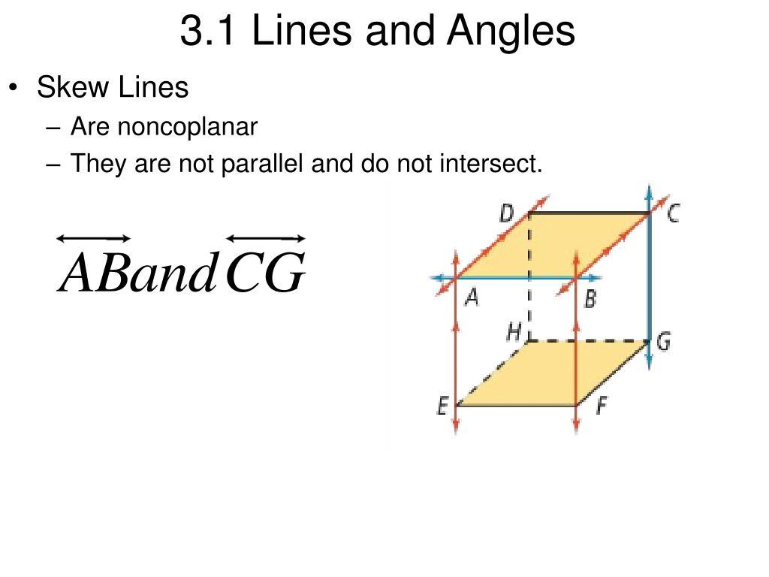
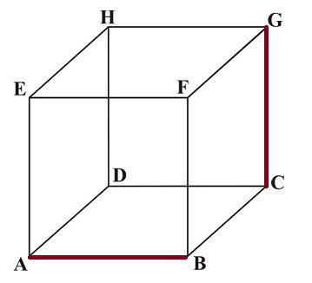
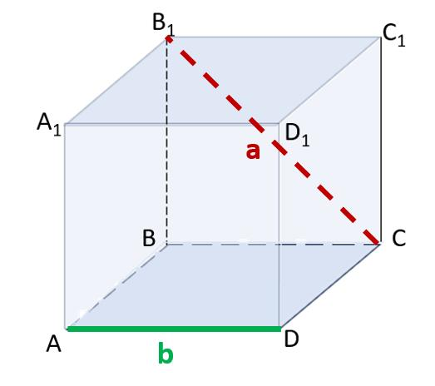

Relationship with Related Geometric Concepts
# Source: AI Source: Provided by: [Data Path: Persons Table -> ID Column: 1, Name_En Column: Motasem Essam] -> From: [ChatGPT] on [7/25/2026]
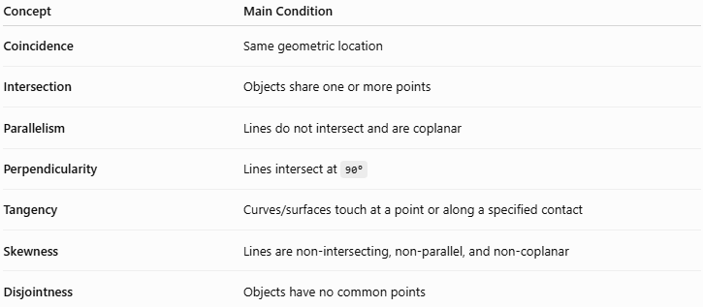
Concept | Main Condition
Coincidence | Same geometric location
Intersection | Objects share one or more points
Parallelism | Lines do not intersect and are coplanar
Perpendicularity | Lines intersect at 90°
Tangency | Curves/surfaces touch at a point or along a specified contact
Skewness | Lines are non-intersecting, non-parallel, and non-coplanar
Disjointness | Objects have no common points

Real-World Applications
# Source: AI Source: Provided by: [Data Path: Persons Table -> ID Column: 1, Name_En Column: Motasem Essam] -> From: [ChatGPT] on [7/25/2026]
Skewness appears in:
- Architecture – relationships between structural members.
- Mechanical engineering – shafts and rods positioned in 3D.
- Robotics – spatial relationships between robotic arms and components.
- Computer graphics – representing 3D lines and objects.
- Construction – analyzing beams and structural elements.
- Aerospace engineering – spatial positioning of components.
- 3D modeling – determining relationships between edges and lines.
- Navigation and spatial analysis – representing objects in three-dimensional space.

Advantages
# Source: AI Source: Provided by: [Data Path: Persons Table -> ID Column: 1, Name_En Column: Motasem Essam] -> From: [ChatGPT] on [7/25/2026]
- Provides a precise way to describe 3D line relationships.
- Distinguishes non-coplanar lines from ordinary parallel lines.
- Helps analyze complex spatial structures.
- Provides a basis for calculating shortest distances between 3D lines.
- Useful in engineering, architecture, robotics, and computer graphics.

Limitations
# Source: AI Source: Provided by: [Data Path: Persons Table -> ID Column: 1, Name_En Column: Motasem Essam] -> From: [ChatGPT] on [7/25/2026]
- Skewness applies to lines in three-dimensional space, not ordinary 2D line geometry.
- A 2D drawing can make skew lines appear to intersect or be parallel.
- Determining non-coplanarity can require vector or coordinate methods.
- The term is generally used for lines rather than arbitrary geometric objects.

Key Points
# Source: AI Source: Provided by: [Data Path: Persons Table -> ID Column: 1, Name_En Column: Motasem Essam] -> From: [ChatGPT] on [7/25/2026]
- Skewness is a relationship between two lines in 3D space.
- Skew lines do not intersect.
- Skew lines are not parallel.
- Skew lines are not coplanar.
- Skewness cannot occur between two distinct lines in a single plane.
- The shortest distance between skew lines is measured along a common perpendicular.
- The vector test
$$\left(\vec{b}-\vec{a}\right)⋅\left(\vec{u}×\vec{v}\right)≠0$$
indicates non-coplanarity.
- Skewness belongs under Geometric Relationships → Positional Relationships.
- In your taxonomy, it is best treated as a distinct relationship rather than as a type of intersection.

Conclusion
# Source: AI Source: Provided by: [Data Path: Persons Table -> ID Column: 1, Name_En Column: Motasem Essam] -> From: [ChatGPT] on [7/25/2026]
Skewness describes the spatial relationship between two lines that are non-intersecting, non-parallel, and non-coplanar. It is fundamentally a concept of three-dimensional geometry. Unlike parallel lines, which can always be placed in a common plane, skew lines occupy different spatial planes and therefore never meet. The concept is especially important in solid geometry and provides the foundation for determining the shortest distance between two lines in space.

